Mattel Disney Princess Modular Slant Back Floor Stand

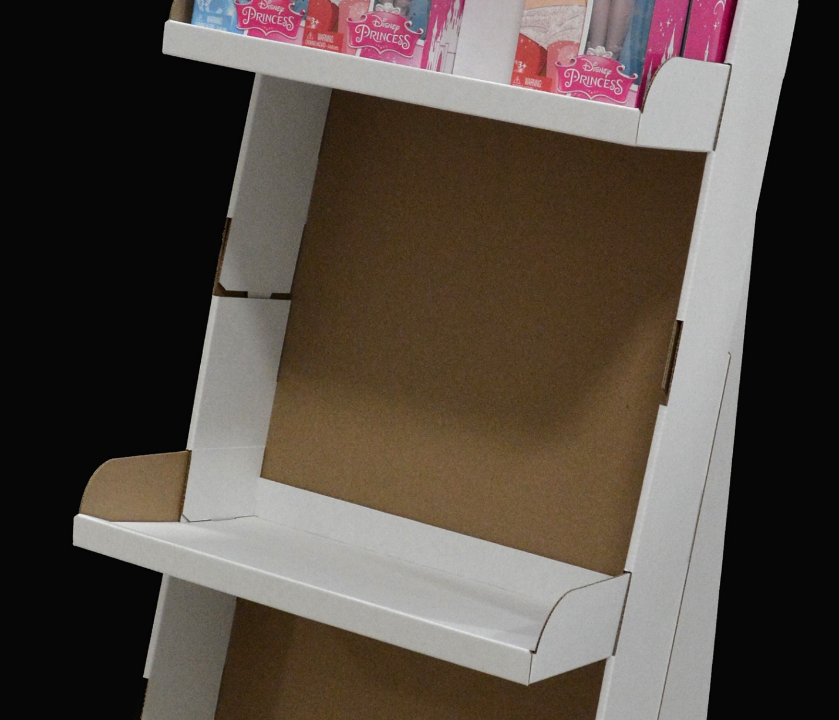
Products Promoted: Individually packaged Disney Princess dolls. This is a pre-pack display.

Objective: Create a universal (modular) floor stand solution that would dramatically reduce production and co-packing costs.

Yearly, Mattel executes thousands of custom floor stand displays for all of their major brands (Barbie, Hot Wheels,
Matchbox, Monster High, etc). In an ongoing effort to reduce display related costs, Mattel turned to GNI to develop a universal system
that would dramatically accomplish this goal.

Solution: GNI created a solution that utilizes a common tray and base and (4) different depths of shelving. This shelving can be positioned
at various levels to accommodate varying heights of Mattel packaging. Additionally, all components, except the header, are "overall" printed
or left white to minimize cost and to ease inventory control. A palette of (4) colors (including white), based on brand colors, was chosen for the program.

Unique Features/Benefits: Past designs included deep trays/cells that diminished the visibility of the product to the consumer. Newly designed
shelving cantilevers from the main tray structure and greatly improves product awareness/availability. Additionally, a reduction of material utilized in the trays construction
translated to a lower component cost.

-Reduced volume of component inventory at co-packer/GNI (VMI – Vendor Managed Inventory). Learning curve for display setup/packing is greatly reduced/eliminated
due to the use of common components for all programs.

-All designs incorporate litho mounted headers (common cutting die — same configuration for all displays).

-Retailers are praising the reduced foot print, which eases in-store placement.

-The execution of this floor stand design and the proposed 1/4, 1/2 and full pallet configurations came from a concerted effort from the entire Racine Design Team.
Store audits that covered various retail channels, multiple brain storming sessions and the development of numerous white samples all contributed to the final solutions.

-The development of this modular floor stand system was key to retaining the Mattel account. This solution was a tremendous "win" for GNC and for Mattel.
Key design elements are currently being incorporated into 1/4, 1/2 and full pallet proposals.

Display life: 2 – 4 weeks

