Perrier "Extraordinary" Pallet/Pole Topper
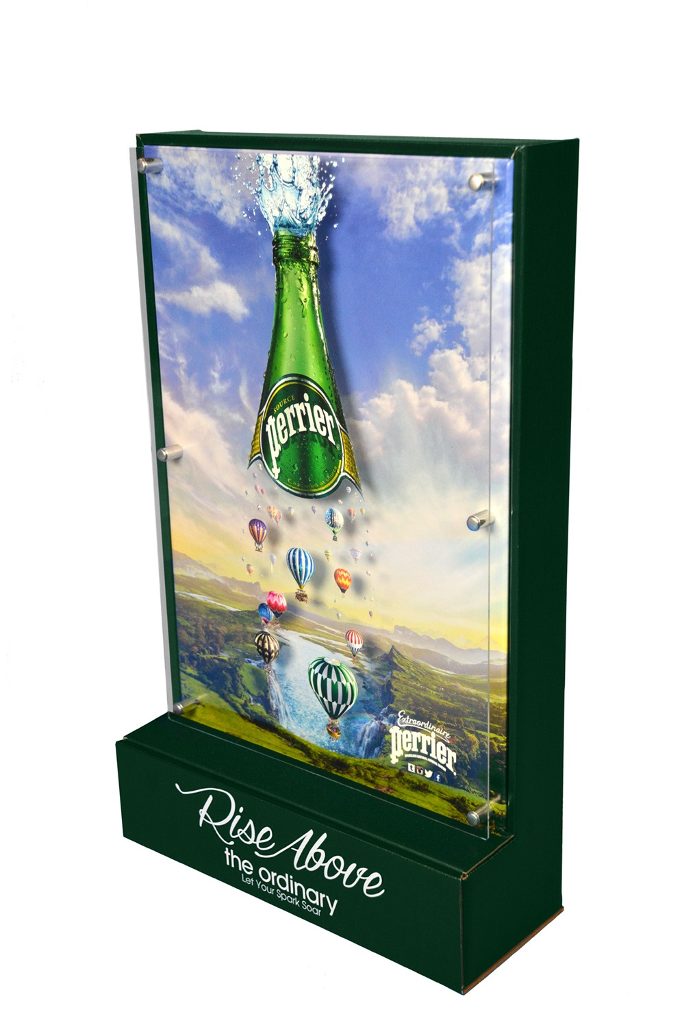

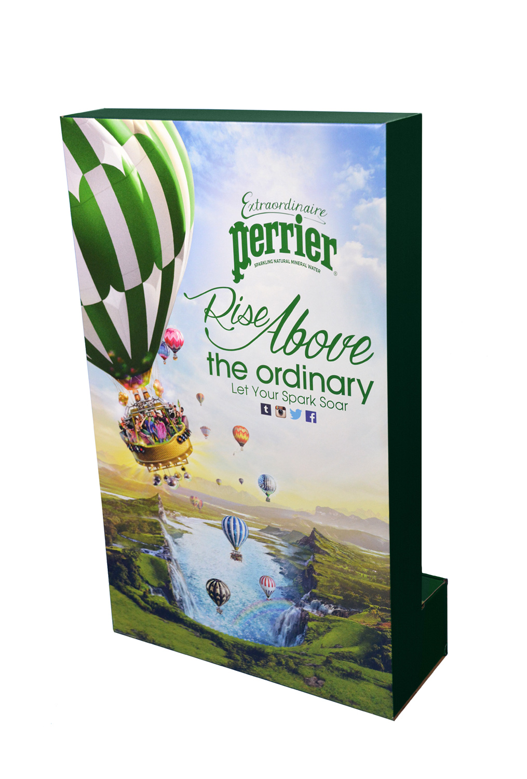

Qty: 1000

Customer: Nestle Waters

Size: 22"H x 16"W x 6"D (w/o pole)

Project goal was to develop a unique pallet/pole topper that would showcase/promote Perrier's "Rise Above" promotional graphic elements
(specifically, the dramatic bottle/balloon imagery).

Solution:
GNI’s design team developed a unique semi-perm 360 degree viewable solution that included a first surface digitally printed .080” acrylic panel suspended (w/ aluminum standoffs) over a litho mounted corrugate structure.This layer created additional dimensionality and heightened the illusion of the bottle and balloons floating over the illustrated landscape. The highly detailed imagery and a clear “call to action” (Rise Above the Ordinary –Let Your Spark Soar) were key elements that attracted the discerning “Perrier” consumer.
This flexible design can be utilized on the top of a pallet stack or as a pole topper when combined with the provided fiber poles and "hollywood" wire feet.
This signage structure was shipped pre-assembled, which eased in-store execution.

