Title: San Pellegrino Singles DRP (Direct Retail Pallet)

Objective: Create a pallet display solution that would securely ship single serve 12 ounce cans to nationwide retail
locations. Ease of instore execution and the need to convey a strong Italian esthetic were also imperative.

San Pellegrino has traditionally shipped pallets into retail with separate point-of-sale elements (dress out kits, floor standing pylons, etc.)
that would be assembled on or around the product stack. The goal of the DRP program is to make the display promotion an integral
part of the shipping pallet.

Solution: The customer, Nestle-Waters, chose a unique fruit cart like structure from GNI's deck of concept renderings. Brilliantly colored graphics reinforced
the fresh fruit flavors that were available on the pallet while a three dimensional handle, lugged foam cor wheels and a cobblestone
pallet cover reinforced the cart and Italian themed aesthetic. A unique infrastructure of layered honey comb panels guaranteed the needed support/integrity needed
during transit and for the life of the promotion.

Unique Features and Benefits:
-Layers of 4" thick honeycomb were pinwheeled around the center graphic column to form the false bottom platform.
-All major components were litho mounted corrugate.
-Handle brackets are constructed from powder coated 18 gauge steel while the handle is a litho mounted fiber pole.
-Litho mounted foam cor cart wheel lugs.
-Multiple ship tests were executed that identified the structure could support 928 lbs (final weight of merchandised product was 654 lbs).
-30 pt layer pads were inserted under the Italian produced product trays to reduce tray disintegration (caused from cans rubbing against tray bottoms).
-Additional graphic elements are exposed (on center column) as product shops down.

Execution: Pallet shroud, cap and shipping fillers are removed, pallet skirt is folded down (tab locking in place) and four sided header (which
ships flat on pallet stack) is erected and drops onto interior column. Execution time is less than 7 minutes.

Retailers praised the minimal amount of time needed for instore execution and the solid construction of the display. Additionally, the cart theme created a high level
of visual excitement that caused consumers to pause, investigate and ultimately purchase San Pellegrino. Product sold through during the promotional period.

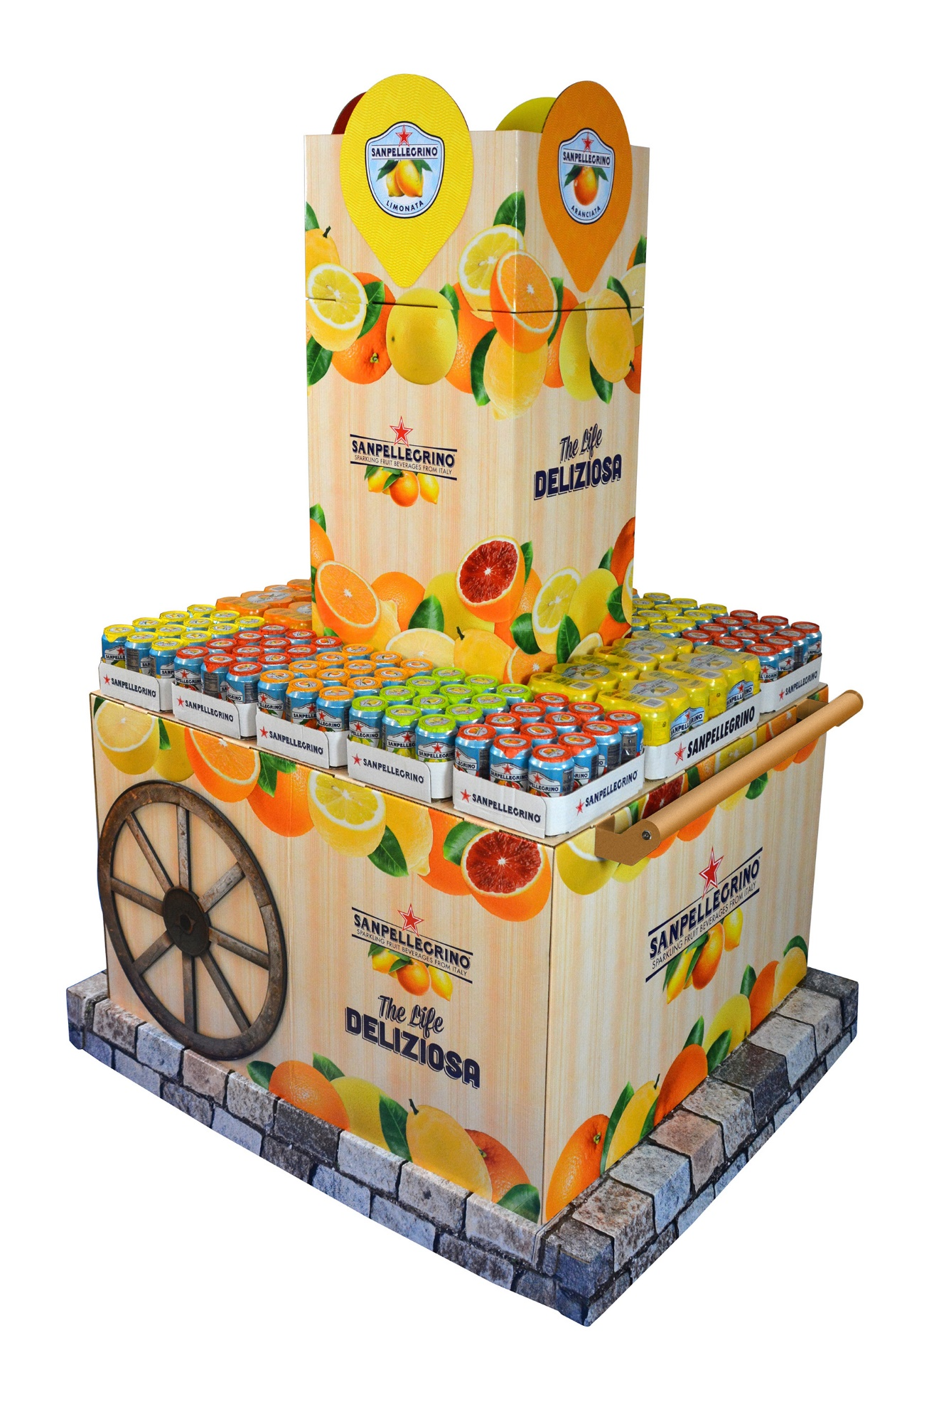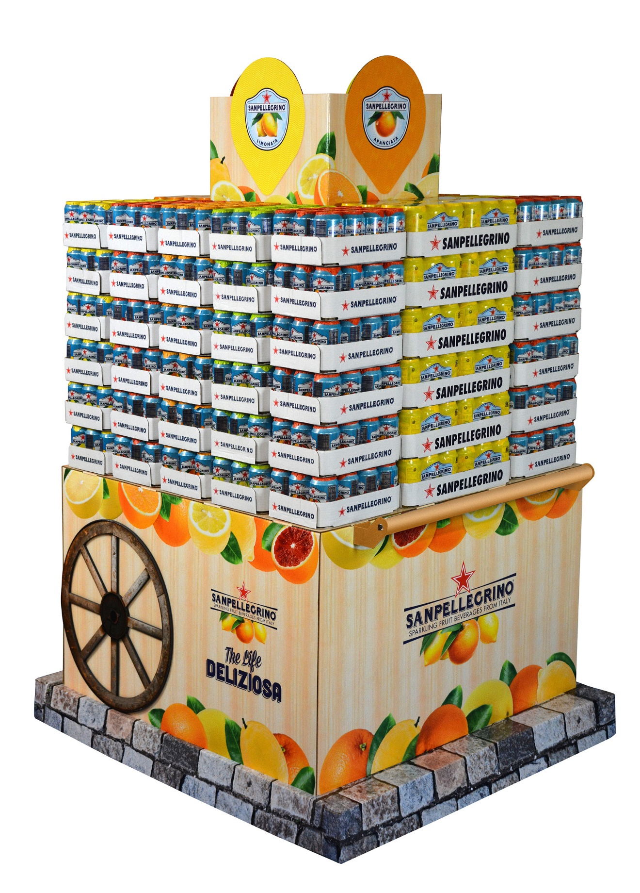

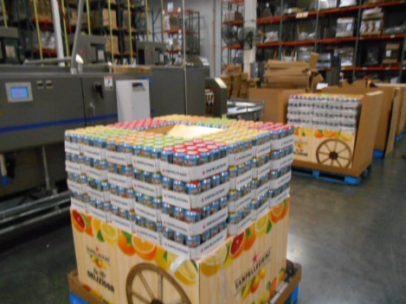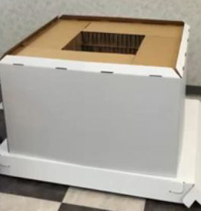
Co-pack Honeycomb Detail

